Instruction manual advanced lab course on spatial and temporal distortions of ultrashort light pulses

Introduction
In research ultrashort light pulses are used to investigate dynamics in complex materials samples on ultrashort timescales, e.g., for time-resolved optical spectroscopy to learn about the dynamics of electrons, lattice and spins. For such studies and the interpretation of the results, it is necessary to understand how ultrashort laser pulses are modified by the interaction with various optical elements in the optical path. For the present experiment, students will make use of a femtosecond laser source (Spectra Physics Tsunami) to generate ultrashort light pulses. Using a commercial pulse characterization device (Swamp Optics Grenouille) they will study how different optical elements (mirrors, prisms, lenses, optical filters, …) modify the temporal and spatial dispersion of ultrashort light pulses. They will learn which kinds of dispersion occur, how those dispersion effects can be described and controlled. With these measurements, they will obtain practical knowledge about non-linear optics and the difference between cw light and ultrashort light pulses for optics.

Questions for Preparation
Please inform yourself about laser safety using a class 4 laser source and think about safe working procedures for working with high power laser sources!
How can you describe ultrashort laser pulses and how they are influenced by dispersion? What are typical characteristics to describe ultrashort laser pulses temporally and spectrally?
How can you characterize the pulse spatially and temporally?
Briefly discuss autocorrelation, FROG and GRENOUILLE.
Which kind of pulse changes can be characterized with GRENOUILLE? What is the origin of these changes?
SHG FROG or SHG GRENOUILLE has an ambiguity in the direction of time. In which way might that be important?
Why do you need a prism compressor and what is its operation principle?
What are the differences between metallic and dielectric mirrors?
What is the difference between normal lenses and achromats?
Recall the optical setup of a telescope.
If you want, you can download a test version of vChirp and make yourself familiar with the simulation software:
https://www.laserquantum.com/products/detail.cfm?id=82&language=de

Experimental Setup
The experimental setup consists of:
- a Spectra Physics Tsunami femtosecond laser source (P_{AVG}= 400 mW, f = 76 MHz, pulse duration τ_{P}≈25 fs) with a central wavelength of typically 800 nm and a gaussian spectral full width at half maximum (FWHM) of typically 40-60 nm (both tuneable) as a light source, which is capable of producing sub-30 fs light pulses;
- Ocean Optics spectrometer for the spectral characterization of the Tsunami
- a Swamp Optics Grenouille pulse characterization device (Model 8-20-USB), capable of measuring pulse durations from 20 – 200 fs, as well as spatial chirp and pulse front tilt;
- optical setup with multiple beam paths to detector and different optics
  - prism compressor (GVD compressor)
  - beam path 1:
    - set of silver mirrors
    - option 1: optical windows consisting of 5/10/15 mm BK7 or 5 mm MgF2, glass wedge
    - option 2: 2:1 beam telescope from BK7, MgF2, or achromatic doublet lenses
    - option 3: shortpass / longpass filter (cut-off/on wavelength 800 nm)
  - beam path 2:
    - dielectric mirrors
  - beam path 3:
    - square mirror pair with 5 bounces on each mirror
- Alignment tools: IR laser cards (3), IR active iris apertures (5)
- Laser safety googles: Three pairs, green filters, mandatory usage!
- Software:
  - Ocean Optics spectrometer software (PC1),
  - Grenouille-Software (QuickFrog) (PC2)
  - vChirp-Software for the simulation of pulse distortions (lab-external PC)

Notes on Safety
You are working with a class 4 laser system in your experiment, which constitutes a severe eye hazard. Therefore, some simple rules apply at all times:
- Never use the Laser without laser safety googles!
- Avoid putting your hands into the beam.
- Before adding something to the beam path block the laser and take care of reflexes!
- Never remove a beam dump without knowledge of the following beam path!
- If you change beam paths or use a beam path for the first time you have to follow the beam from optic to optic to make sure that no stray light or unwanted reflexes occur.
- Never leave the room without blocking the laser in front of the Tsunami!
- You are not allowed to be alone in the room!
You should receive further basic instruction on laser safety from your experiment supervisor. Adhere to them and if anything is unclear ask for clarification.

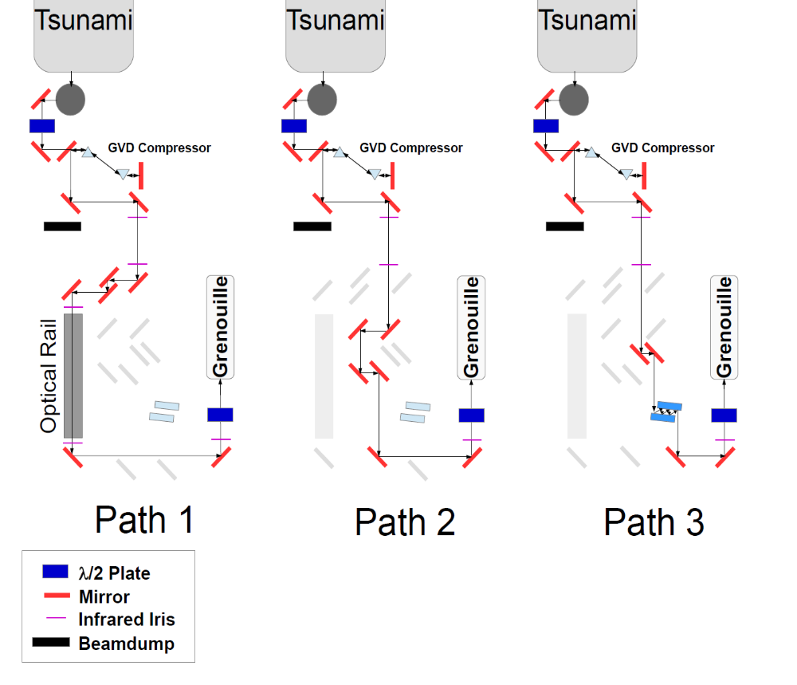
Abb 1: Sketch of the 3 optical Paths.

How to work with optical setups
- As you will wear Laser safety googles at ALL times during the experiment, you have several infrared viewing cards at your disposal to make the beam visible. In addition, you have several IR Iris apertures, which you can put into their respective holders to align the beam through your setup. Both are marked by color-coded tape for the respective positions. For the telescopes, you have a screw in IR iris with crosshair to align the telescope into the beam path.
- When you setup the different beam path the safe (and only) way to work is that you follow the beam from optic to optic using typically two IR cards, so that the beam is never allowed to propagate freely, until you know the beam path is safe. If you do not know how to do this, ask your advisor for help.
- The way to adjust your beam through the iris apertures works as follows. Two iris apertures always define a level path for the beam. To align the beam through these two apertures you have to use two mirrors in front of the two apertures, such that you use the first mirror to adjust on the first aperture and the second mirror to adjust on the second aperture. This procedure (beam walking) is iteratively repeated until you pass through both iris apertures in a satisfactory manner. The beam has to be blocked behind the second aperture by a beam dump, while doing so, as well as possible using an IR card for the first alignment through the first onto the second aperture or when necessary, i.e. for large deviations where an alignment can lead to the beam leaving the iris.
- Putting optics into a beam path is only allowed if the beam path is blocked before the optic in question!
- For the GRENOUILLE you first align roughly into the Grenouille using the two provided iris apertures and then use the second iris aperture and the spatial Grenouille cam for fine tuning!
- If you are unsure, ask your advisor!

Tasks
The principle experimental task is to measure the influence of different optical elements on the laser pulse characteristics for at least two spectral bandwidths of the laser, one large (e.g. 50-55 nm FWHM) and one small (e.g. 25 nm FWHM). After you finished task 1 to 4, please ask your advisor, to tune the laser bandwidth. Do NOT adjust the Tsunami laser source on your own.
The evaluation part consists of explaining the observed experimental results and modelling them using analytical approximations for some of the experimental data, as well as a comparison to numerical modelling from the vChirp software.
Notes on optics handling: Optics are delicate and sometimes expensive and may even be damaged by touching them. Wear gloves when handling optics, do only touch them at the borders and if you inadvertently touch an optic on the optic surface, please inform your advisor if cleaning seems necessary or damage has occurred. Do NOT drop optics. Never leave them on a surface on the optics side.
Before starting with the experiment, get familiar with the three optical paths for your own safety!
- Prism compressor: Use only the prism compressor in conjunction with beam path 1 (only silver mirrors, no added elements). What is a prism compressor good for? Study the influence of prism insertion on the measured laser properties for at least 5 different positions of the second prism (use micrometer screw and note down positions, you need to have one position where the laser beam just passes through the apex of the prism), note down results and save the data for later analysis. What is the optimum prism compressor position and why (Discuss with advisor)? You also need the prism distance for the evaluation of data. The prisms themselves are made of LaKL21 (10LK10 from Newport).
NOTE ON SAFETY: IT IS EASY TO REMOVE A PRISM FROM THE BEAM PATH INADVERTEDLY, WHICH LEADS TO A FREELY PROPAGATING BEAM! BE CAREFUL WHILE CHANGING THE PRISM INSERTION! CHECK THAT THE LASER TABLE HOUSING IS INSTALLED BEHING THE PRISMS, THAT NO BEAM CAN LEAVE THE TABLE ACCIDENTALLY!
- Put the prism compressor in optimum configuration (note down prism insertion). Use beam path 1 to study the influence of different optical elements on the pulse properties:
  - Note down results and take data with only mirrors for optimum prism configuration. Before each experiment put the compressor back in optimum position again!
  - Start with option 1:
    - Use 1/2/3 elements of BK7 glass in the beam path (you can screw them together). Take data, try to compensate the observed changes with the prism compressor for each case. Note down the changes, save all needed data for later analysis.
    - Compare 1 element BK7 glass with 1 MgF2 glass (each 5 mm thick), take data, try to compensate observed changes, save data.
    - Use 1 BK7 glass element. Tilt it by about ±30° (both) with respect to the optical axis. (This is a potentially dangerous thing to do! Why? Discuss with advisor beforehand!) After tilting the glass element, make sure that you align the beam into the GRENOUILLE again! Take data, try to compensate with prism compressor, save all data.
    - Replace the BK7 glass with a BK7 wedge (6° wedge) close to a mirror behind it. Adjust into Grenouille. Take data, try to compensate with prism compressor, save all data.
  - Option 2: Put prism compressor in optimum configuration for silver mirrors. Setup 1:2 telescopes using the pairs of
    - BK7,
    - MgF2 and
    - achromatic lenses.
How do you make sure that your telescope is setup optimally? Take data, try again to compensate changes with prism compressor. Note down and save results.
  - Option 3: Put prism compressor in optimum configuration. Setup either long- or shortpass filter, note down results and save files for later analysis. Does the prism compressor help here?
- Put prism compressor in optimum configuration without optics. Change beam path to 2. Note down and save data. Try to compensate with prism compressor.
- Put prism compressor in optimum configuration without optics. Change beam path to 3. Note down and save data. Try to compensate with prism compressor or BK7 glass. Take and save data
- Repeat (1, 2.b.i, 2.c.i, 2.c.iii, 3, 4) for a strongly different laser bandwidth (talk to advisor to adjust tsunami).

Evaluation of data
- First discuss, how ultrashort laser pulses are different from cw laser light and which special effects occur for ultrashort laser pulses compared to (nearly) cw laser light (Keywords: Time-bandwidth product, fourier transform limit, temporal and spatial distortion).
- After experiment, evaluate data for the different configurations and for the different laser bandwidths:
  - Explain, what prism compressor does. Compare your calculations to experimental results and vChirp modelling. A full version of the vChirp software is available from your advisor.
  - Compare different mirrors in beam path 1-3: What effects are visible and how are these mirrors suited for use with ultrashort laser pulses. What are their properties (esp. beam path 3)?
  - Evaluate the effects of windows on the pulse properties both qualitatively and quantitatively (own calculations and vchirp). What are the differences for different thicknesses and materials? What additional effects are introduced by tilting the glass or using a glass wedge?
  - Compare the effects of the different types of beam telescopes qualitatively. Which one is best suited for the use with ultrashort laser pulses?
- Critize the setup and the manual constructively

Notes on File Format
The FROG traces are output to disk as ExpFrog.dat (the experimentally measured trace) and RetrFrog.dat (the reconstructed or retrieved trace).
The file format is as follows:
Number of delays
Number of wavelengths
delay_stepsize
wavelength_stepsize
center_wavelength
data. . .

The files containing E-field information are:
- ETemporal.dat - the retrieved electric field in the time domain.
- ESpectral.dat - the spectrum of the retrieved electric field.
The format for all these files is a 5-column format, with the following values:
Time (or wavelength) Intensity Phase (in radians) Real Part of Field Imaginary Part of Field

Units for the time axis are femtoseconds, for the wavelength axis are nanometers.

Literature
- Jean-Claude Diels, Wolfgang Rudolph, Paul F. Liao, and Paul Kelley: “Ultrashort Laser Pulse Phenomena : Fundamentals, Techniques, and Applications on a Femtosecond Time Scale”, electronically available from the SUB
- Femtosecond Laser Pulses : Principles and Experiments / edited by Claude Rullière
- Rick Trebino: Frequency-resolved optical gating: the measurement of ultrashort laser pulses.
- Ulrike Fuchs: Fokussierung ultrakurzer Laserpulse – Dissertation Universität Jena 2009 (http://nbn-resolving.de/urn:nbn:de:gbv:27-20100210-153840-4)
- www.refractiveindex.info
- Selcuk Akturk et.al., OPTIC EXPRESS, Vol. 11, No. 1, 68, 2003
- Selcuk Akturk et.al., OPTIC EXPRESS, Vol. 11, No. 5, 491, 2003

